**VRChem: Chemistry Laboratory Automation**

*Xiaokang Guo1*

1Department of Chemistry, New York University, New York, NY 10003, United States

Aims

Chemistry laboratory is where new molecules are conceptualized on the whiteboard, synthesized in the fume hood, and analyzed by machines (such as LC/MS, NMR, and diffractometer). In contrast to the widespread adoption of sample-analysis machines, automated systems for chemical synthesis are rare. There have been apparatus-level attempts, in which glassware was equipped with programmable valves, pumps, and sensors (Fig. 1a).1-5 More advanced systems have employed customized reaction chambers (Fig. 1b).6-8 Labor-level attempts have also been made, in which generic glassware was managed by robots.9, 10 In all cases, the synthesis system was developed by chemical engineers or chemists with strong engineering backgrounds, and the operation required skillful programming or scripting, for which most chemists were not trained. I believe that the automation paradigm should be transformed into building and operating a user-friendly and general-purpose robotic system.

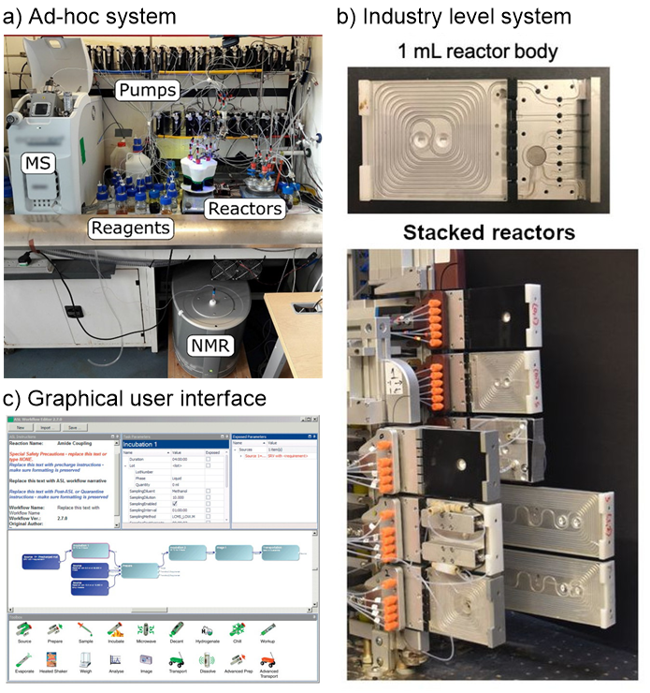

**Figure 1**. Different systems but the same design paradigm: ad-hoc system (a) vs. industry-grade machine (b). The latter provides a graphical user interface for planning, operating, and monitoring.

*Aim 1.* ***Every chemist can use the system.*** The system needs to provide a user-friendly human-machine interface (HMI), which is the crux of a new automation paradigm. Experimental chemists have fine craftsmanship in building their own experimental setups. The robotic system should help them fulfill their primary role as chemists, and its usage should draw zero attention to engineering and programming.

*Aim 2.* ***It should be general-purpose.*** The system should perform labor-level automation, so that it will not be bound to a specific research field. Chemists from most sub-disciplines of chemistry should be able to use the same robotic system to automate their laboratories.

*Aim 3.* ***Low cost of laboratory transformation.*** The system needs to transform the current laboratory with no renovation and, ideally, work with chemists seamlessly. Its components should be commercially available at low cost.

*Aim 4.* ***New ways of training chemists and being chemists****.* Part of the system should be able to train chemistry students economically, efficiently, and safely. The system should enable remote working for experimental chemists and free them from hazardous environments, repetitive operations, and heavy work, especially for female chemists.

Innovation

An excellent perspective from Godfrey guides us through a gallery of engineering marvels in chemistry laboratory automation.11, 12 However, on one hand, it is impracticable for chemists to spend months to build an ad-hoc system, which can only be used in few experiments. On the other hand, most systems lack user-friendly human-machine interfaces, which prevent the widespread adoption. Some researchers invented new chemical programming languages5, 13 to support cross-platform applications (program a chemical experiment once, run it across robotic platforms). Advanced systems may provide a graphical user interface (GUI, Fig. 1c) but the learning curve is still steep. I would like to introduce a robotic chemistry laboratory powered by the virtual reality (VR) technology, which can address all the above problems. The room, workbenches, immovable equipment, and moveable apparatus of a real laboratory (Fig. 2a) are 3D scanned and digitized to create a virtual laboratory (Fig. 2b). After spending 10 minutes learning the basics, a chemist can start setting up an experiment with generic glassware and then perform it intuitively in the virtual lab. The location and orientation of each building component of the experimental setup, and the movement of hands and fingers will be automatically recorded and sent to the control unit of a robot (Fig. 2c) in the real lab. Finally, the robot repeats all received actions in the real laboratory faithfully.

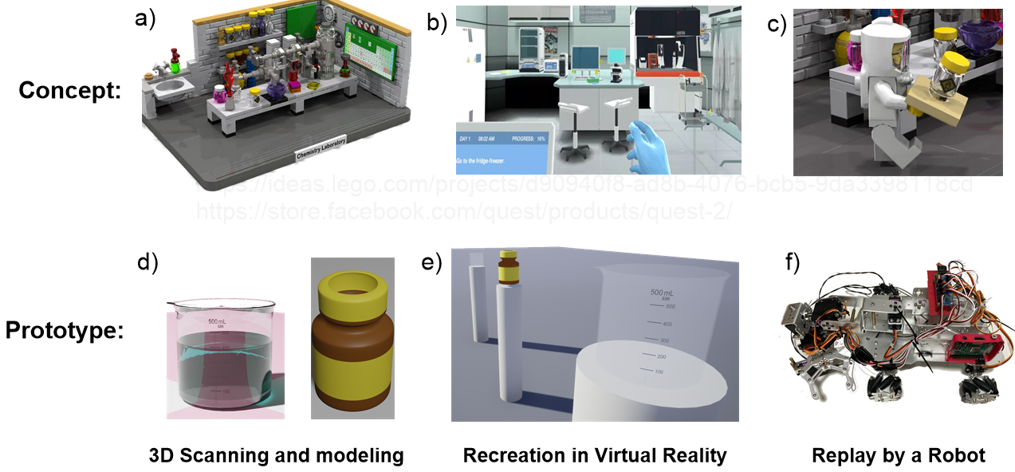

**Figure 2.** Concept of a VR-powered robot system consists of three parts: 3D scanning of (a) a real laboratory, (b) virtual laboratory, and (c) robot. In prototyping, I modeled some (d) apparatus, developed (e) a VR application of the reagent transfer operation, and programmed (f) a robot to follow all my actions performed in the VR application.

Significance

I believe this labor-level robot system can revolutionize how chemists work and cooperate. No robot system known before has almost no learning curve and allows chemists to use it visually and intuitively at this level. Due to its general-purpose nature, the automated laboratory can be managed by a dedicated team and shared across the research institution. In addition, some experiments, such as organometallic reactions, are intrinsically dangerous. Even a professor and a renowned researcher died of laboratory accidents.14, 15 The robotic system will save lives. Moreover, the VR-powered system also benefits skill sharing among the scientific community. One chemist can share his/her experiments with all the details. His/her operations can become a standard, which will be edited, rearranged, and incorporated into others’ experiments. For example, after one chemist demonstrated the preparation of standard solution in the virtual lab, all other chemists can copy the demonstration and their robots know how to prepare standard solutions in real laboratories.

A Hypothetical Application

When the chemist found that the red Kaede chromophore could be synthesized in a one-step ZnCl2 catalyzed condensation between the *p*-HDBI and an aldehyde, the robustness of the protocol was tested with various aldehydes (Fig. 3). The following application will demonstrate the benefits of a VR-powered robotic system in the organic synthesis experiment.

After putting up the VR headset, the user speaks out the equipment s/he needs, then a 3-neck round bottom flask, a condenser, a heating mantle, and a stir bar appear on the virtual bench (because of an AI feature). These apparatuses are assembled by the user into the wanted experimental setup (Fig. 3b). Reagents are chosen from the inventory, then *p*-HDBI, tetrahydrofuran, 4-nitrobenzaldehyde (**1**, Fig. 3a), and the anhydrous ZnCl2 catalyst appear in different beakers. The reagents are then transferred into the flask. The stir and heat knobs are adjusted so that the virtual reaction begins. The user presses a “goto” button (Fig. 6a) and sets the virtual time to 4 hours later when the reflux is supposed to finish. The user then performs remaining tasks, such as purification and bench cleaning. The whole demonstration process is duplicated five times and only the aldehyde-choosing action is adjusted to synthesize other Kaede chromophores (**2**-**6**, Fig. 3a). Finally, the user exits the VR application, and the robot performs the experiments in the real laboratory.



**Figure 3**. a) One-step condensation mechanism with different aldehydes. b) Set of the condensation experiment.

Prototyping

To validate the idea of using virtual reality in chemistry experiment automation, I prototyped a VR-enabled robotic system that can perform one operation in the hypothetical application: transferring the anhydrous ZnCl2 catalyst from its original bottle into a beaker. The *GNU Image Manipulation Program* (GIMP, Fig. 4a) was used to prepare the texture (graduation lines and marks) of the beaker and the bottle models. *Blender* was used to model the beaker and the bottle. The *Unreal Engine* (*UE*) is an integrated platform of VR application development. It supports 3D model importing, map editing (everything in VR is part of the map), and is tightly bound with *Microsoft Visual Studio* for C++ programming. The VR application was developed in the *UE* and deployed to a *Meta Oculus Quest 2* (*Quest 2*, Fig. 4b). The *Quest 2* wirelessly reported the movement of beaker to a control application, which was written in *Python* and run on a *Raspberry Pi 3A+* of the robot. The control application processed and interpreted the report as control signals of the servos of the robot arm. Eventually, the robot arm was able to transfer the catalyst from its original bottle to a chosen beaker in the VR application.

I shared a demonstration video on Youtube at <https://youtu.be/g1j7a0Utpd8>. As shown in the video, I moved the bottle freely in the VR application (called VRChem), and the robot arm performed the exact same series of maneuvers in reality.

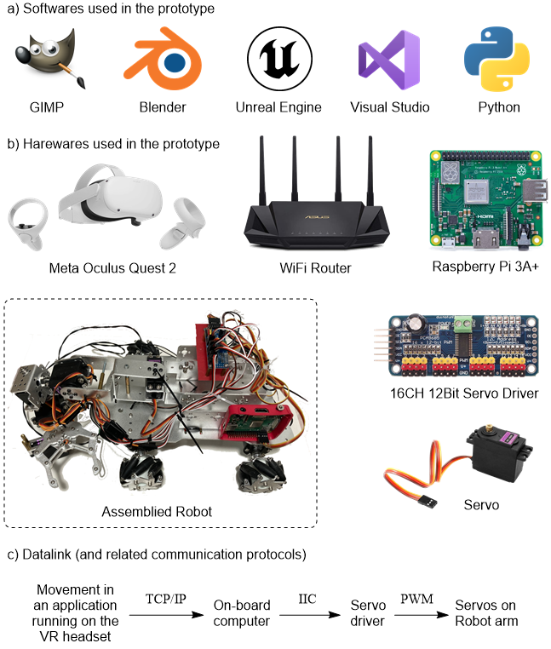

**Figure 4.** The software (a) and hardware (b) used in the prototyping work.

Approach

Based on the work in the prototyping section, an automated chemistry laboratory comprises two subsystems: the virtual laboratory application and the robot.

**Virtual Laboratory Application**

A chemist’s real laboratory will be duplicated via the 3D scanning, 3D modelling and programming. The long-range laser 3D scanner (Fig. 5a) captures large objects, such as the laboratory room, workbenches, and fume hoods. The portable 3D scanner (Fig. 5b) captures small- or medium-sized objects, such as flasks, breakers, centrifuges, and HPLC systems. These scanners have sub-millimeter precision, and their bundled software can export the scanned models in standard format (Fig. 5c). As most apparatuses in a chemistry laboratory are standardized, the scanning job becomes easy after the first few laboratories.



**Figure 5.** a) The long-range laser 3D scanner has a work range of tens of meters. The scanner shown here is *Artec Ray*. b) The handheld scanner can scan an object at any angle. The scanner I am holding is *CR-Scan 01*. c) A round bottom flask was scanned and the 3D model of the flask was obtained. A scanning spray was used to scan the transparent surface.

Some scanned models, such as workbench or centrifuge, will be imported into the 3D modeling software *Blender* to perform disassembly processing because the moving parts, such as the drawer or the lid, should be separated from the main body of the model. All models, including the processed ones, will be imported into the *Unreal Engine* (*UE*) to reconstruct the virtual laboratory. In the *UE*, the apparatus will be programmed to improve the user experience or mimic their real functionalities. For example, sockets (a VR software mechanism) will be added to glassware like 3-neck round bottom flask and condenser, so they will be coupled automatically when the end of the condenser is moved near the neck of the flask. The Drawer of the workbench and the lid of the centrifuge will be given physical properties, such as movement constraints or hinge mechanisms, so that they will function correctly.

The virtual laboratory will have two-way communication capabilities. It can track the position and orientation of each object and receive feedback from the real laboratory to augment the virtual laboratory. For example, when the chemist plugs a thermometer into one neck of a flask in the virtual laboratory, a WiFi-enabled thermometer will be inserted into the flask in the real laboratory. During the real experiment, the WiFi-enabled thermometer will report the solution temperature so that the temperature can be displayed on the flask in the virtual laboratory.

A *Time Manipulator* mechanism will be implemented to manipulate the time dimension of the virtual laboratory. As shown in Figure 6a, the user was performing an acid-base mixing experiment to investigate the different behaviors of weak and strong acids. In an earlier stage of the experiment, the user needed to transfer three standard solutions into respective test tubes. Using the *Time Manipulator*, the user only needed to transfer one standard solution from the bottle to the tube (Fig. 6b). For the other two tubes, the user activated the edit mode and duplicated (copy-and-paste) the transfer process twice. Additionally, the solution transfer process was saved in a procedure library for future use. The standard solution preparation procedure was also imported from the procedure library and placed ahead of the solution transfer processes on the timeline.



**Figure 6**. User interface of the *Time Manipulator*. a) An acid-base mixing experiment demonstrates the buffer capability of the acetic acid-sodium acetate mixture. b) Solution transfer process.

A sharing website will be developed to hub chemists’ virtual experiments. With the chemist’s permission, the website shares both the virtual laboratory and the experiment recordings. Other chemists can play the recording in their VR headsets, save clips to their procedure library, and reuse it in their own experiments. In addition, students only need the VR headset to practice the experiment and their teacher can grade their experimental skills in the VR system. This would save the time and chemicals.

**Robot**

A two-arm mobile robot will be developed to conduct experiments in real laboratories. An onboard computer receives the moving trajectory of each object in the virtual laboratory. Planning software will find the right way to instruct the robot hand to move the object to follow the moving trajectory. The robot’s mobile platform will be equipped with a *light detection and ranging* (LiDAR) sensor to avoid collision because the robot would share the same laboratory with chemists but at different times.

To reduce the complexity of robot design, we will work with equipment manufacturers and add remote-control features to their products. For example, we will design an ESP8266 microcontroller-based circuit board to wirelessly control the heating mantle so that the robot arms do not need to dial the knobs anymore. Specifically, ESP8266 has a Wi-Fi stack to run a web server and *pulse width modulation* (PWM) method to control the stirring speed and heating rate.

Additional Comment and Outlook

One may ask why VR is favored instead of augmented reality (AR). The answer to this is that AR is limited by reality in certain situations. We cannot fast forward the timeline and skip the 4-hour reflux to do ensuing operations. VR application can be driven by the recorded data. This would allow us to edit the experimental demonstration and replace the aldehyde-choosing clip, which results in multiple 4-hour long demonstrations for the robot to replay. In addition, virtual laboratory can be augmented as well, so VR does not lose any useful features compared to AR.

Although the robotic part of the system is fully compatible with an artificial intelligence (AI) pipeline, I chose not to pursue a design paradigm featuring chemistry AI. First, “strong AI” is unavailable at this moment, which means that an AI-powered system is currently field-restricted. Coley8 tried this path so that their robot system was “trapped” in a particular field of organic synthesis. Their machine cannot be used to synthesize metal–organic frameworks (MOFs) because their organic chemistry AI has no idea what are MOFs. The current status of AI development prevents an AI-powered robot system from being general-purpose (Aim 2). Second, hand movement is a simple input form that can easily be repeated by a simple-minded robot. The job can be finished by a user-friendly (Aim 1) and economical (Aim 3) robot. Additional AI features are just a burden for the development from my perspective.

By introducing new 3D content, this robot system can be applied in academic/industrial training facilities, manufacturing factories, pharmaceutical laboratories, centralized kitchens, or Mars colonization.

References

1. Masui, H.; Yosugi, S.; Fuse, S.; Takahashi, T., Solution-phase automated synthesis of an alpha-amino aldehyde as a versatile intermediate. *Beilstein J Org Chem* **2017,** *13*, 106-110.

2. Bogdan, A. R.; Dombrowski, A. W., Emerging Trends in Flow Chemistry and Applications to the Pharmaceutical Industry. *J Med Chem* **2019,** *62* (14), 6422-6468.

3. Caramelli, D.; Granda, J. M.; Mehr, S. H. M.; Cambie, D.; Henson, A. B.; Cronin, L., Discovering New Chemistry with an Autonomous Robotic Platform Driven by a Reactivity-Seeking Neural Network. *ACS Cent Sci* **2021,** *7* (11), 1821-1830.

4. Li, J.; Ballmer, S. G.; Gillis, E. P.; Fujii, S.; Schmidt, M. J.; Palazzolo, A. M.; Lehmann, J. W.; Morehouse, G. F.; Burke, M. D., Synthesis of many different types of organic small molecules using one automated process. *Science* **2015,** *347* (6227), 1221-6.

5. Steiner, S.; Wolf, J.; Glatzel, S.; Andreou, A.; Granda, J. M.; Keenan, G.; Hinkley, T.; Aragon-Camarasa, G.; Kitson, P. J.; Angelone, D.; Cronin, L., Organic synthesis in a modular robotic system driven by a chemical programming language. *Science* **2019,** *363* (6423).

6. Adamo, A.; Beingessner, R. L.; Behnam, M.; Chen, J.; Jamison, T. F.; Jensen, K. F.; Monbaliu, J. C.; Myerson, A. S.; Revalor, E. M.; Snead, D. R.; Stelzer, T.; Weeranoppanant, N.; Wong, S. Y.; Zhang, P., On-demand continuous-flow production of pharmaceuticals in a compact, reconfigurable system. *Science* **2016,** *352* (6281), 61-7.

7. Bedard, A. C.; Adamo, A.; Aroh, K. C.; Russell, M. G.; Bedermann, A. A.; Torosian, J.; Yue, B.; Jensen, K. F.; Jamison, T. F., Reconfigurable system for automated optimization of diverse chemical reactions. *Science* **2018,** *361* (6408), 1220-1225.

8. Coley, C. W.; Thomas, D. A., 3rd; Lummiss, J. A. M.; Jaworski, J. N.; Breen, C. P.; Schultz, V.; Hart, T.; Fishman, J. S.; Rogers, L.; Gao, H.; Hicklin, R. W.; Plehiers, P. P.; Byington, J.; Piotti, J. S.; Green, W. H.; Hart, A. J.; Jamison, T. F.; Jensen, K. F., A robotic platform for flow synthesis of organic compounds informed by AI planning. *Science* **2019,** *365* (6453).

9. Weber, A.; von Roedern, E.; Stilz, H. U., SynCar: an approach to automated synthesis. *J Comb Chem* **2005,** *7* (2), 178-84.

10. Burger, B.; Maffettone, P. M.; Gusev, V. V.; Aitchison, C. M.; Bai, Y.; Wang, X.; Li, X.; Alston, B. M.; Li, B.; Clowes, R.; Rankin, N.; Harris, B.; Sprick, R. S.; Cooper, A. I., A mobile robotic chemist. *Nature* **2020,** *583* (7815), 237-241.

11. Godfrey, A. G.; Michael, S. G.; Sittampalam, G. S.; Zahoranszky-Kohalmi, G., A Perspective on Innovating the Chemistry Lab Bench. *Front Robot AI* **2020,** *7*, 24.

12. Godfrey, A. G.; Masquelin, T.; Hemmerle, H., A remote-controlled adaptive medchem lab: an innovative approach to enable drug discovery in the 21st Century. *Drug Discov Today* **2013,** *18* (17-18), 795-802.

13. Mehr, S. H. M.; Craven, M.; Leonov, A. I.; Keenan, G.; Cronin, L., A universal system for digitization and automatic execution of the chemical synthesis literature. *Science* **2020,** *370* (6512), 101-108.

14. Safety: Chemist Patrick Harran to face trial on charges related to death of research assistant. *Chemical & Engineering News Archive* **2013,** *91* (18), 9.

15. Mercury poisoning fatal to chemist. *Chemical & Engineering News Archive* **1997,** *75* (24), 11-12.